**CSE421 LAB 02 (NS-3) ID:20301269**

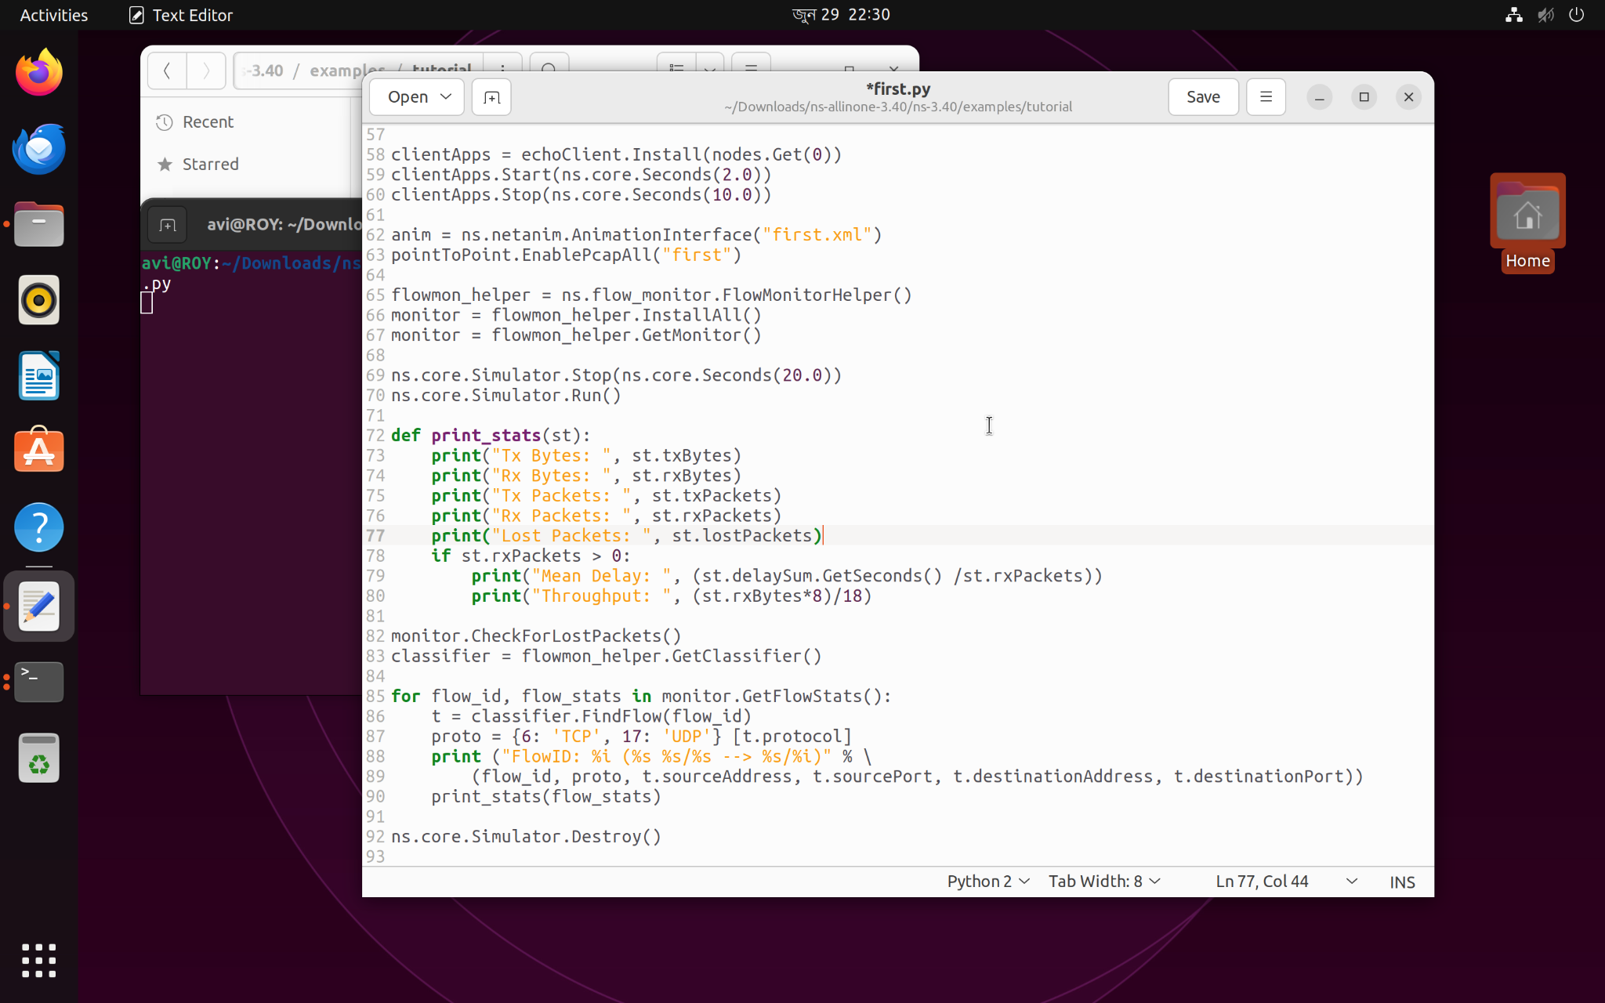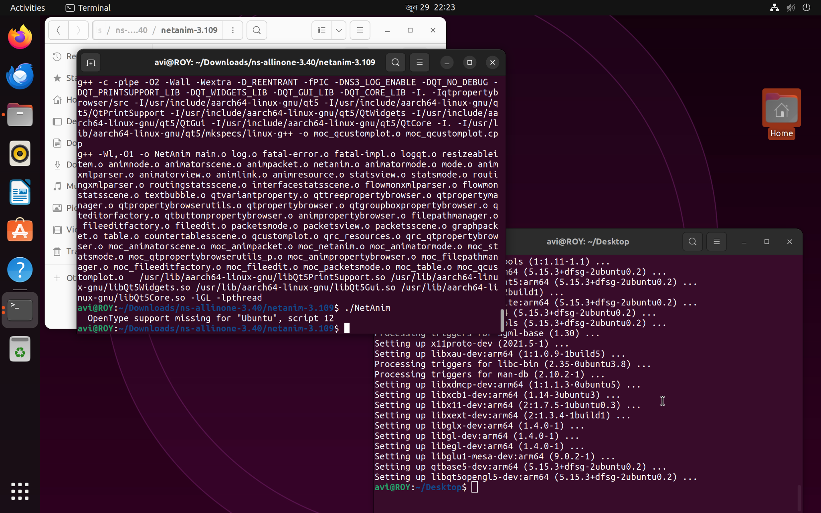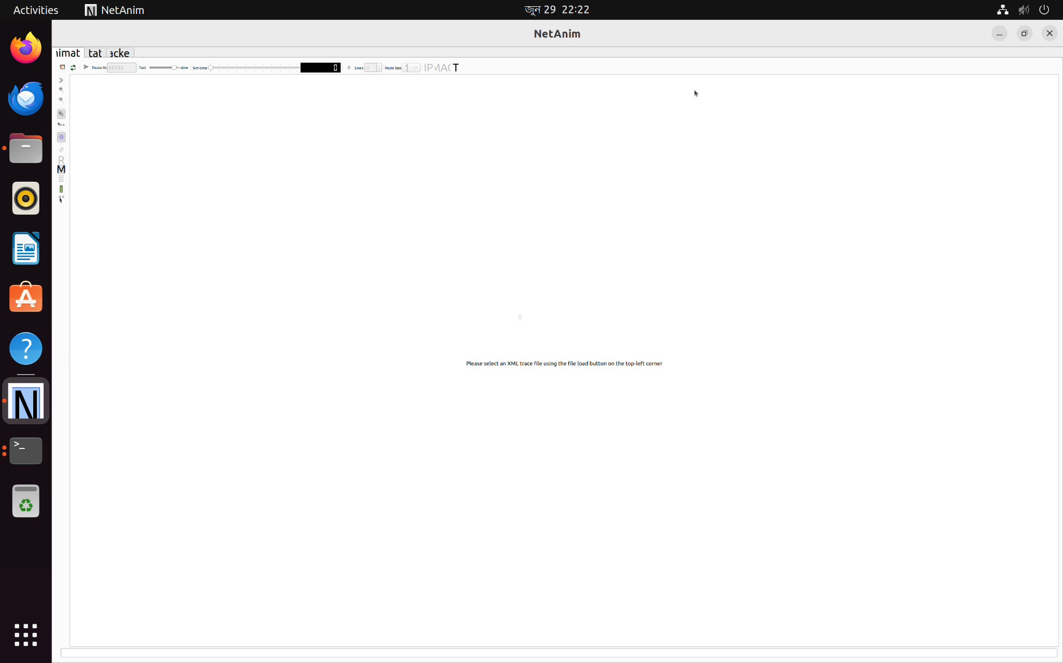

**Outputs for different data sizes:**

**Packet size: 128**

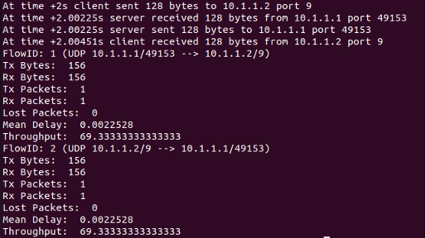

**Packet size: 256**

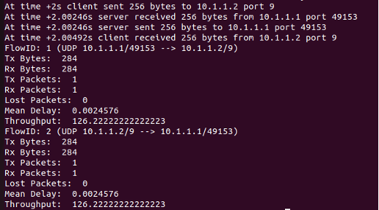

**Packet size: 512**

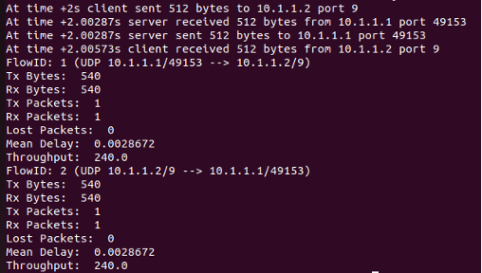

**Packet size: 1024**

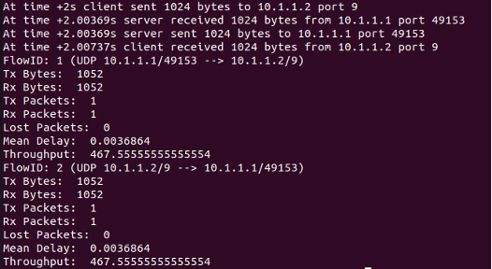

**Packet size: 2048**

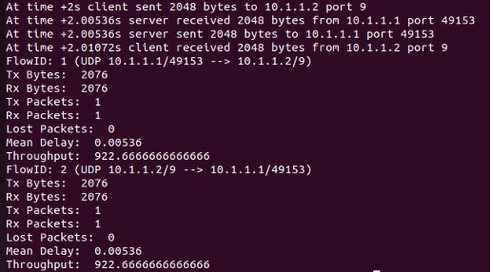

**Graph on Throughput vs Data Size:  
  
  
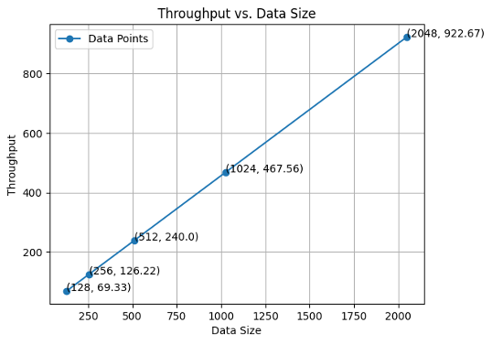**

Efficiency and scalability in data processing are frequently shown by a graph that shows an improvement in throughput as data size grows. When you plot data size on the X-axis and throughput on the Y-axis, you will get a relationship that is linear. In short, a computer network that shows a straight-line graph of throughput vs data size suggests that it can expand linearly. This means that the network's throughput grows in direct proportion to the amount of data being handled.